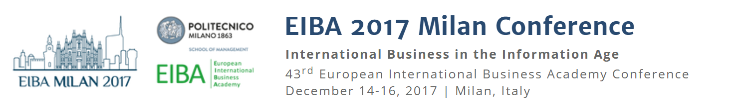

PH.D. GRANT APPLICATION FORM
The organizers of the 43rd EIBA Annual Conference to be held in Milan are pleased to offer 2 PhD stipend grants of €500 euros each for students whose proposals are accepted to the EIBA 2017 doctoral program.
Applications deadline: October 15, 2017
ATTENTION: registration to the EIBA 2017 Milan conference along with acceptance to the doctoral program (i.e., one of the two pre-conference doctoral events) are mandatory requirements for applicants to be eligible for a stipend grant. The organizers will select grant recipients from low-income country institutions, amongst the valid applications received by the deadline date.
Please fill-in this short form and in order to apply for the grant and send this form to: info@eiba2017.org
We are very grateful to Sustainable School of Management (Politecnico di Milano) for the financial support.
Surname:
Name:
Date of birth:
Country of birth:
Nationality:
Home Address:
University Affiliation:
Email:
Doctoral program attended:
31st EIBA / EIASM John H. Dunning Doctoral Tutorial in International Business
6th EIBA / EIASM Danny Van Den Bulcke Doctoral Symposium in International Business

